Technical Datasheet ENC28J60-Based Ethernet Module

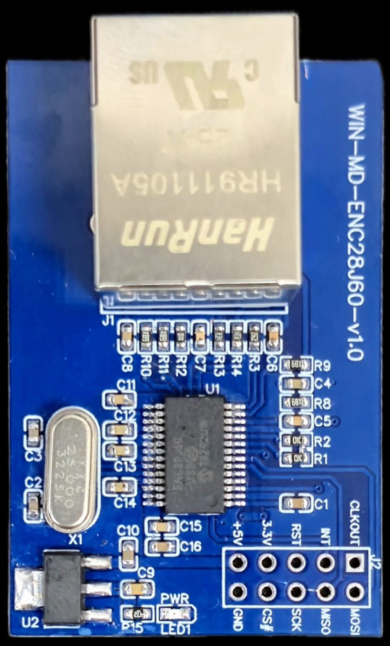
The Ethernet module is based on the ENC28J60, a standalone Ethernet controller with an integrated MAC and PHY. It interfaces with the host microcontroller via a high-speed SPI bus and provides 10 Mbps Ethernet connectivity for embedded applications.

ENC28J60 Module: -

Unlike hardwired TCP/IP controllers, the ENC28J60 operates at the Ethernet frame level and requires the host microcontroller to implement the TCP/IP protocol stack (such as LwIP or uIP). This offers greater flexibility and control over network communication but increases firmware complexity.
The module includes an onboard RJ45 connector with integrated magnetics, ensuring reliable signal integrity and simplified hardware design. It is well-suited for cost-sensitive and customizable networking applications in embedded and industrial systems.
The ENC28J60 module is ideal for applications where full control over networking protocols is required, such as custom communication stacks, lightweight web servers, and specialized industrial communication interfaces

Specifications
General –

Interface SPI (Serial Peripheral Interface)
Ethernet 10 Mbps, RJ45 with Integrated Magnetics
I/O Connector 2 × 5 Pin Header, 2.54 mm Pitch
Dimensions 32.7 mm (L) × 50.0 mm (W)

Power Supply 5V DC / 3.3V DC Input
Certifications

Additional Features: -
Based on ENC28J60
Integrated MAC and PHY supporting 10BASE-T Ethernet
SPI interface for communication with host MCU
Requires external TCP/IP stack implementation (LwIP/uIP)
Onboard RJ45 connector with integrated magnetics
Suitable for low-cost and customizable embedded networking applications
Compact design for easy integration into industrial and IoT systems

Note: -
Use standard CAT5e or higher Ethernet cable for reliable communication.
Ensure proper grounding and stable power supply for optimal performance.
SPI lines should be kept short and properly routed to minimize signal noise.
Adequate firmware stack (TCP/IP) is required on the host controller.


ETHERNET
PORT
Common GND
5V & 3.3V Input Supply

SPI INTERFACE
CONTROL & CLOCK SETTING
Power LED

Contact us: -

Augmatic Technologies Pvt. Ltd.,
Plot no 6, Shah Industrial Estate II,
Kotambi,
Vadodara – 391510.
Email – Sales@wittelb.com

